Exercise 1: Write Testable Code with Moq
Objective: The objective of this exercise is to perform unit testing using the NUnit framework and Moq library. The application contains a mail-sending module that communicates with an SMTP server. To avoid sending real emails during testing, a mock object is used for the IMailSender dependency.

Problem Statement
The Customer Communication module sends emails to customers after transactions. Directly testing the MailSender class is difficult because it depends on an external SMTP server. To achieve loose coupling and faster execution, dependency injection and mock objects are used.

Task 1: CustomerCommLib Implementation
A Class Library project named CustomerCommLib was created. The following components were implemented:
• IMailSender Interface
• MailSender Class implementing IMailSender
• CustomerComm Class using constructor dependency injection

Task 2: Unit Testing with NUnit and Moq
A separate test project named CustomerComm.Tests was created. NUnit was used for writing test cases and Moq was used to create a mock implementation of IMailSender. The mock object was configured to accept any string parameters and always return True.

Solution Explorer

The solution contains two projects: CustomerComm Lib and CustomerComm.Tests.

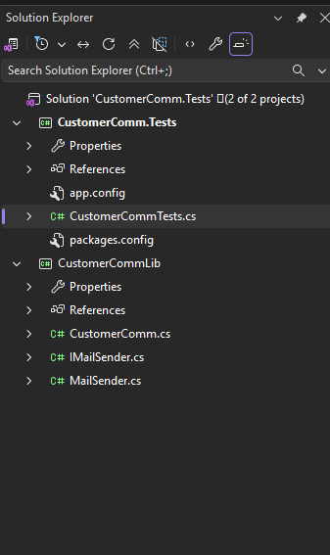

CustomerCommTests.cs
The test class uses TestFixture, OneTimeSetUp and TestCase attributes. A mock object is configured using Moq.
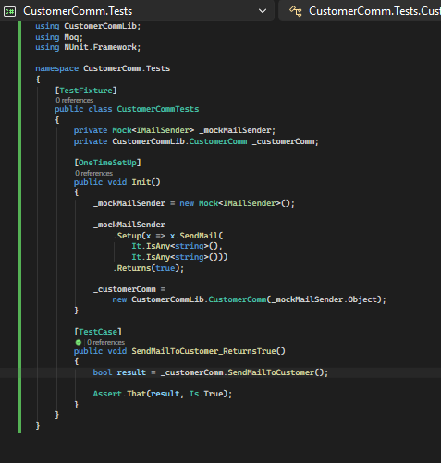

CustomerComm.cs
CustomerComm receives the IMailSender dependency through constructor injection and invokes SendMail().
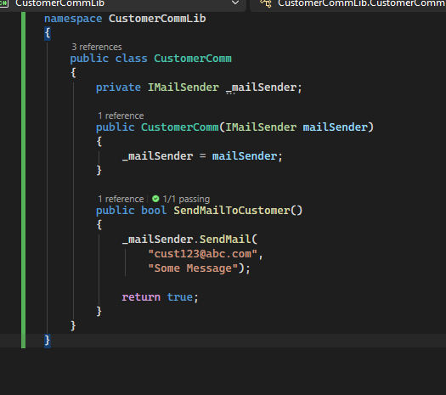

IMailSender.cs
The interface defines the SendMail method contract.
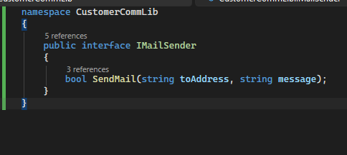
MailSender.cs
MailSender implements the IMailSender interface.
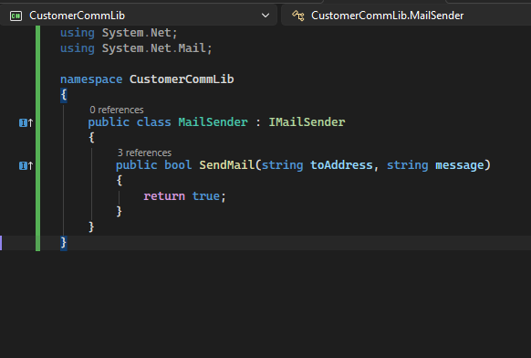

Test Execution Output
The test was executed successfully and the result was passed.
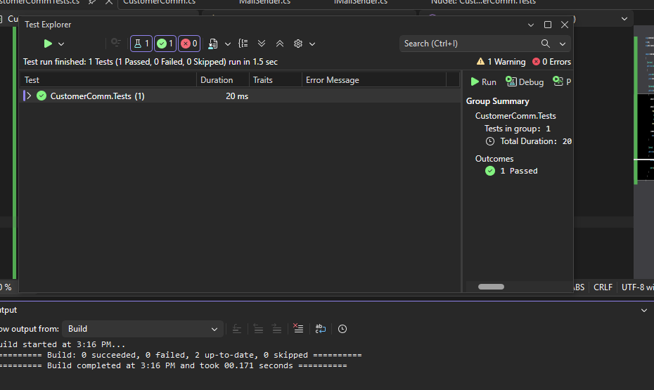

Result
The unit test was executed successfully using NUnit and Moq. The IMailSender dependency was mocked, eliminating the need for actual SMTP communication. The method SendMailToCustomer() returned True as expected.
Test Name : SendMailToCustomer_ReturnsTrue
Tests Run : 1
Passed : 1
Failed : 0
Skipped : 0

